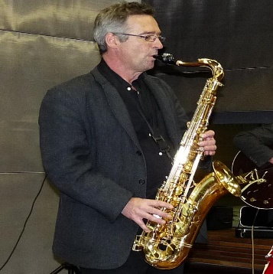
Professor Dr.-Ing. Gerhard Fischerauer
Universität Ulm
Fakultät für Ingenieurwissenschaften, Informatik und Psychologie
Abteilung für Mikro- und Nanomaterialien
Albert-Einstein-Allee 47 89081 Ulm
Webseite

Short Summary
Prof. Dr.-Ing. Ulrich Herr, born in 1961 in Trier, is a renowned figure in the field of Materials Science. His academic journey began at the Universität Saarbrücken where he studied Materials Science from 1980 to 1986. He further pursued his doctorate in Engineering Sciences under the guidance of Prof. Herbert Gleiter, focusing his research on “Multi-component nanocrystalline materials”. His exceptional work earned him the Dr. Eduard Martin Prize. In 1991, he joined the Institute of Physics at the Universität Augsburg as a research associate, working closely with Prof. Konrad Samwer. During his tenure, he spent a year at the Materials Research Laboratory of the University of Illinois in Urbana-Champaign (USA) with Prof. R.S. Averback. His relentless pursuit of knowledge led him to habilitate in Experimental Physics at the Universität Augsburg in 1998, after which he was appointed as a private lecturer. In December 1999, he accepted a professorship for Materials of Electrical Engineering at the Universität Ulm. His current research interests lie in the exploration of nanocrystalline phosphors, magnetoresistance sensing, magnetic nanoparticles, and nanotechnology for photovoltaics.
Publications
- Xu, J., Herr, U., Klassen, T., & Averback, R. S. (1996). Formation of supersaturated solid solutions in the immiscible Ni–Ag system by mechanical alloying. Journal of applied physics, 79(8), 3935-3945.
- Klassen, T., Herr, U., & Averback, R. S. (1997). Ball milling of systems with positive heat of mixing: Effect of temperature in Ag-Cu. Acta materialia, 45(7), 2921-2930.
- Hofmann, M., Naumoski, H., Herr, U., & Herzog, H. G. (2015). Magnetic properties of electrical steel sheets in respect of cutting: Micromagnetic analysis and macromagnetic modeling. IEEE Transactions on Magnetics, 52(2), 1-14.
- Naumoski, H., Riedmueller, B., Minkow, A., & Herr, U. (2015). Investigation of the influence of different cutting procedures on the global and local magnetic properties of non-oriented electrical steel. Journal of Magnetism and Magnetic Materials, 392, 126-133.
- Trampenau, J., Bauszus, K., Petry, W., & Herr, U. (1995). Vibrational behaviour of nanocrystalline Ni. Nanostructured materials, 6(5-8), 551-554.

Lectures / Seminars
- Materials Science I/II
- Thin Films
- Computational Methods
- Einführung in die Werkstoffe
- Dünnschichttechnologie

