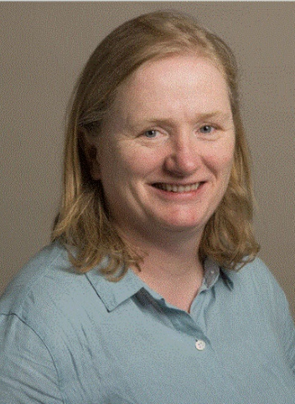
Professor Dr. Nora Dempsey
Institut Néel
Département Nanosciences
25 av. des Martyrs
38042 GRENOBLE Cedex
FRANKREICH
Webseite

Short Summary
Dr. Nora Dempsey is a renowned scientist known for her exceptional research in the field of micro and nanomagnetism. She is a staff researcher at the Institut Néel in Grenoble, France. Her work primarily involves the study of magnetic systems at the micro and nano scales, spanning from fundamental research to applications in spintronics, energy, and life sciences. In 2021, Dr. Dempsey was awarded the prestigious CNRS Innovation Medal, a distinction that recognizes individuals whose exceptional research has led to significant technological, economic, therapeutic, and social innovations. This award was in recognition of her work related to the fabrication, characterization, and use of high-performance micro-magnets. Some key milestones in her career include her recruitment by the CNRS in 2001, the start of her collaboration with Toyota Motor Corporation in 2007, and her first publication on high-performance hard magnetic NdFeB films. In 2013, she patented the use of micro-magnets for molecule capture, a technology that is now exploited by the start-up Magia Diagnostic. In 2016, she achieved the first magnetic characterization using a Kerr effect magneto-optical system with a patented pulsed magnetic field source. In 2019, she initiated the MicroMagFab maturation project. Dr. Dempsey’s work has had a profound impact on the field of micro and nanomagnetism, and she continues to drive innovation in this area.
Publications
- Joseph J, Fontana E, Devillers T, Dempsey N, Kohl M. "A Gd-Film Thermomagnetic Generator in Resonant Self-Actuation Mode". Adv. Funct. Mater. 2023; 33: 2301250.
- Delshadi S, Fratzl M, Ramel O, Bigotte P, …, Dempsey N, Devillers T, Halfon P, Leroy A, Weidenhaupt M, Marche P. "Magnetically localized and wash-free fluorescence immunoassay (MLFIA): proof of concept and clinical applications". Lab. Chip. 2023; 23: 645-658.
- Kovacs A, Fischbacher J, Özelt H, Kornell A, Ali Q, Gusenbauer M, ..., Dempsey N, Fukushima T, Akai H, Kawashima N, Miyake T, Schrefl T. "Physics-informed machine learning combining experiment and simulation for the design of neodymium-iron-boron permanent magnets with reduced critical-elements content". Front. Mater. 2023; 9: 1094055.
- Bastian F, Melayah D, Hugoni M, Dempsey N, Simonet P, Frenea-Robin M, Fraissinet-Tachet L. "Eukaryotic Cell Capture by Amplified Magnetic in situ Hybridization Using Yeast as a Model". Front. Microbiol. 2021; 12: 759478.
- Eslava GG, Ito M, Colin C, Yano M, Shoji T, Kato A, Suard E, Dempsey N, Givord D. "Preferential Co and Fe atom occupancy in R₂(Fe_{1-x}Co_{x})₁₄B intermetallic compounds (R = Nd, Y and Ce)". Journal of Alloys and Compounds. 2020; 851: 156168.
Lectures / Seminars
None (according to available info)

