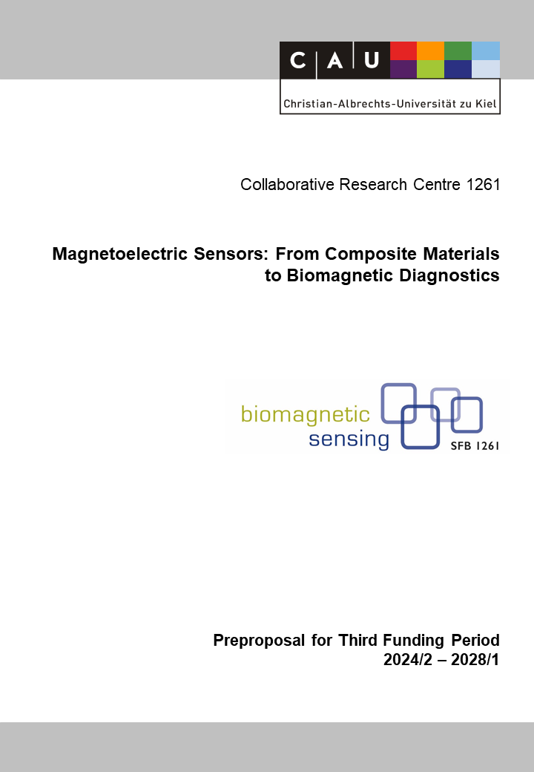

Z2: Magnetoelectric Sensor Characterization
Reviewer (to be removed finally) | Benjamin Spetzler
Reviewer (to be removed finally) | Walter Maetzler
Reviewer (to be removed finally) | Lorenz Kienle

Principal Investigators
Höft, Michael, Prof. Dr.-Ing.  02.07.1972, German  Microwave Engineering  Institute of Electrical and Information  Engineering  Christian-Albrechts-Universität zu Kiel  Kaiserstr. 2, D-24143 Kiel  Phone: +49 (0) 431 880 6150  E-mail: mh@tf.uni-kiel.de | Rieger, Robert, Prof. Dr.  26.10.1975, German  Networked Electronic Systems  Institute of Electrical and Information  Engineering  Christian-Albrechts-Universität zu Kiel  Kaiserstr. 2, D-24143 Kiel  Phone: +49 (0) 431 880 6151  E-mail: rri@tf.uni-kiel.de
Summary of the Service Project
The primary objective of this central project is to characterize the individual magnetoelectric sensors that are being investigated and manufactured in the A projects. Due to the intricacies of sensor fabrication, magnetoelectric sensors cannot be identically processed by default, leading to performance deviations for each individual sensor. Therefore, a robust link between the sensor fabrication and their different intended (bio-)medical applications becomes important. To ensure reproducible sensor performance and provide quantitative feedback to the fabrication projects, a variety of quantitative metrics have already been successfully defined and implemented. These metrics include assessing the frequency response, noise amplitude spectral density, input-output-amplitude relation, limit-of-detection, limit-of-quantification, bandwidth, and dynamic range, among others. Additionally, the suite of current metrics will undergo expansion and refinement to encompass emerging requirements. New metrics will be developed and implemented based on an in-depth analysis of the unique needs and performance aspects of the current (bio-)medical applications. The data accumulated from the evaluation will be utilized to implement robust and insightful quality assurance protocols. Furthermore, an expansion of the ongoing exchange with the Physikalisch-Technische Bundesanstalt, Germany's leading authority on metrology and measurement technology, is planned. This will enable more general quality assurance of the magnetoelectric sensors. Additionally, the already established evaluation metrics will be collaboratively together with them for a more general magnetometer evaluation and comparison, addressing the current lack of a regulatory standard.
In order to ensure a reproducible magnetic operation point, a comprehensive investigation will be carried out focusing on an initialization method of the ME sensors based on equilibration. This approach aims to establish a standardized procedure and takes the hysteric effects caused by the magnetostrictive layer into account. Moreover, support in sensor selection for all (bio-)medical application projects, ensuring optimal operation within their specific contexts, will be provided. This support will include guidance during the sensor selection process, provision of technical advice concerning functionality, and assistance in the integration of selected sensors into magnetoelectric systems or for appropriate use in medical studies. Continuous feedback and collaboration with these projects will foster further refinement of the sensors. Additionally, support is provided to medical personnel in the preparation of related experiments involving both healthy subjects and patients is provided. The hardware currently available within this central project, including amplifiers, signal generators, stimulators, and interfaces, will be continuously upgraded and expanded, in close collaboration with project B1.

Project-relevant Previous Publications
[1] Elzenheimer, E.; Hayes, P.; Thormählen, L.; Engelhardt, E.; Zaman, A.; Quandt, E.; Frey, N.; Höft, M.; Schmidt, G.: Investigation of Converse Magnetoelectric Thin Film Sensors for Magnetocardiography, IEEE Sensors Journal 23 (6), 2023, 5660-5669, doi: 10.1109/JSEN.2023.3237910.
[2] Wang, H.; Arbustini, J.; Elzenheimer, E.; Schell, V.; Höft, M.; Quandt, E.; Schmidt, G.; Heidari, H.; Bahr A.: Study of Chopping Magnetic Flux Modulation on Surface Acoustic Wave Based Magnetic Sensor, 29th IEEE International Conference on Electronics, Circuits and Systems, 2022, 1-4, doi: 10.1109/ICECS202256217.2022.9970919.
[3] Muñoz, J.; Arbustini, J.; Elzenheimer, E.; Hoffmann, J.; Thormählen, L.; Hayes, P.; Niekiel, F.; Heidari, H.; Höft, M.; Quandt, E.; Schmidt, G.; Bahr A.: Digital Approaches on Frequency Tuning for Magnetoelectric Sensors, 29th IEEE International Conference on Electronics, Circuits and Systems (ICECS), 2022, doi: 10.1109/ICECS202256217.2022.9970919.
[4] Arbustini, J.; Muñoz, J.; Wang, H.; Elzenheimer, E.; Hoffmann, J.; Thormählen, L.; Hayes, P.; Niekiel, F.; Heidari, H.; Höft, M.; Quandt, E.; Schmidt, G.; Bahr, A.: MEMS Magnetic Field Source for Frequency Conversion Approaches for ME Sensors, Current Directions in Biomedical Engineering 8 (2), 2022, 309-312, doi: 10.1515/cdbme-2022-1079 (open access).
[5] Wolframm, H.; Schell, V.; Quandt, E.; Höft, M.; Bahr, A.: High sensitivity magnetoelastic surface acoustic wave (SAW) magnetic field sensors, Proc. SPIE 12205, Spintronics XV, 1220505 (3 October 2022), doi: 10.1117/12.2633398.
[6] Elzenheimer, E.; Bald C.; Engelhardt, E.; Hoffmann, J.; Hayes, P.; Arbustini, J.; Bahr A.; Quandt, E.; Höft, M.; Schmidt, G.: Quantitative Evaluation for Magnetoelectric Sensor Systems in Biomagnetic Diagnostics, Sensors, 22 (3), 1018, 2022, doi: 10.3390/s22031018 (open access).
[7] Simmich, S.; Rieger, R.: Analysis of Current-Reuse and Split-Voltage Topology for Biomedical Amplifier Arrays, IEEE PRIME, Villasimius, Italy, 2022, doi: 10.1109/PRIME55000.2022.9816819.
[8] Spetzler, B.; Wiegand, P.; Durdaut, P.; Höft, M.; Bahr, A.; Rieger, R.; Faupel, F.: Modeling and Parallel Operation of Exchange-Biased Delta-E Effect Magnetometers for Sensor Arrays, Sensors, 21 (22), 7594, 2021, doi: 10.3390/s21227594 (open access).
[9] Simmich, S.; Bahr, A.; Rieger, R.: Noise Efficient Integrated Amplifier Designs for Biomedical Applications, Electronics, 10 (13), 1522, 2021, doi: 10.3390/electronics10131522 (open access).
[10] Rieger, R.; Rif’an, M.: Integrated ExG, Vibration and Temperature Measurement Front-End for Wearable Sensing, IEEE Trans. Circuits Syst. I - Reg. Papers, 65(8), (2018) 2422–2430, doi: 10.1109/TCSI.2017.2785863.

