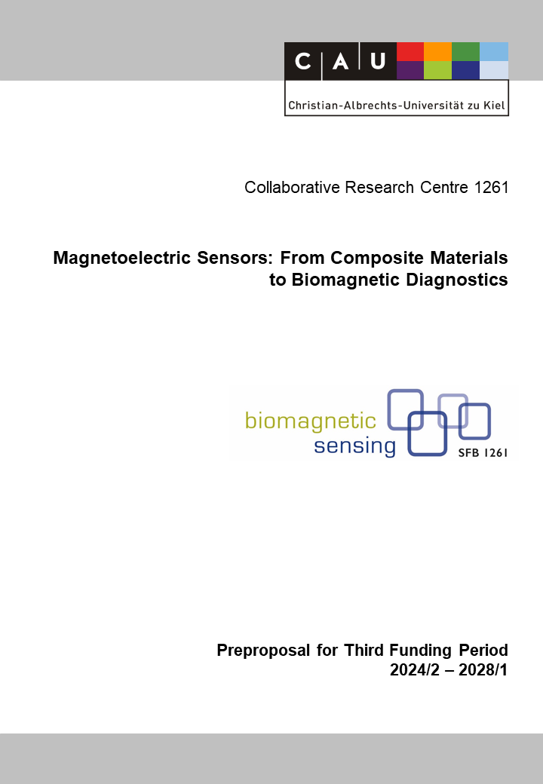

Z1: MEMS Magnetoelectric Sensor Fabrication
Reviewer (to be removed finally) | Andreas Bahr
Reviewer (to be removed finally) | Rainer Adelung
Reviewer (to be removed finally) | Robert Rieger

Principal Investigators
Meyners, Dirk, Dr.  22.05.1973  Inorganic Functional Materials  Institute for Materials Science  Christian-Albrechts-Universität zu Kiel  Kaiserstr. 2, D-24143 Kiel  Phone: +49 (0) 431 880 6202  E-mail: dm@tf.uni-kiel.de | Gojdka, Björn, Dr.-Ing.  20.01.1981  MEMS Applications  Fraunhofer Institute for Silicon Technology ISIT  Fraunhoferstr. 1, D-25524 Itzehoe  Phone: +49 (0) 4821 17 1412  E-mail: bjoern.gojdka@isit.fraunhofer.de
Summary of the Service Project
The central task of the project is to fabricate magnetoelectric sensors in large numbers and with high reproducibility so that they can be reliably used in the CRC’s application projects of research area B. For this purpose, a technology platform has been established during the current funding period. The platform combines the micro- and nanosystems capabilities offered by the cleanroom laboratories at the two sites of CAU and ISIT.
In the Kieler Nanolabor at CAU, the sensor fabrication is based on bulk micromachining combining magnetron sputter deposition, plasma enhanced chemical vapor deposition, conventional optical lithography, ion beam etching, wet chemical etching, and reactive ion etching. The following techniques are also available for possible future development: pulsed laser deposition, atomic layer deposition, electro plating, electron beam lithography, and laser writing.
The 200 mm wafer line at ISIT offers a wide range of back-end-of-line processes for MEMS manufacturing. Examples include vacuum wafer-level packaging, highly selective gas-phase etching by XeF₂, grinding and chemical-mechanical polishing, (thick) polysilicon on silicon oxide, deep reactive ion etching, micro assembly processes, atomic layer deposition, RF and DC sputter deposition, electro plating, spin and spray coating, stepping and 1:1 lithography as well as comprehensive measurement equipment for process control monitoring. Furthermore, ISIT provides it’s propietary PowderMEMS microfabrication technique. It allows for the wafer-level integration of functional three-dimensional microstructures like magnets or dense seismic masses.
In the current period, the bulk micromachining of miniaturized cantilever sensors for direct detection and ΔE-effect read-out was a main work package. The process flow has been revised twice with the help of failure mode effect analysis and specific design rules. The technology platform has been extended to bulk SAW sensors and A projects have been supported by partially processed wafers.
For the funding period to be applied for, it is expected that these core tasks will remain. In addition, the project will adopt fabrication processes for the newly introduced converse ME sensors.
By repeatedly adapting the technology platform to the latest findings, Z1 fulfills its central role as an interface between the projects of the sensor research area A and the projects of area B dedicated to sensor application. An important aspect of the platform revisions will be the implementation of ISIT’s PowderMEMS technology which will contribute integrated magnetic structures to the CRC, e.g. for integrated bias and AC magnetic field sources.

Project-relevant Previous Publications
[1] Niekiel, M. F.; Meyer, J. M.; Lewitz, H.; Kittmann, A.; Nowak, M. A.; Lofink, F.; Meyners, D.; Zollondz, J.-H.: What MEMS Research and Development Can Learn from a Production Environment. Sensors, 23 (2023), 5549. DOI: 10.3390/s23125549 (open access).
[2] Schell, V.; Spetzler, E.; Wolff, N.; Bumke, L.; Kienle, L.; McCord, J.; Quandt, E.; Meyners, D.: Exchange biased surface acoustic wave magnetic field sensors. Scientific reports, 13 (2023), 8446. DOI: 10.1038/s41598-023-35525-6 (open access).
[3] Bodduluri, M. T.; Dankwort, T.; Lisec, T.; Grünzig, S.; Khare, A.; Ahmed, M.; Gojdka, B.: Fully Integrated High-Performance MEMS Energy Harvester for Mechanical and Contactless Magnetic Excitation in Resonance and at Low Frequencies. Micromachines, 13 (2022). DOI: 10.3390/mi13060863 (open access).
[4] Bodduluri, M. T.; Gojdka, B.; Wolff, N.; Kienle, L.; Lisec, T.; Lofink, F.: Investigation of Wafer-Level Fabricated Permanent Micromagnets for MEMS. Micromachines, 13 (2022). DOI: 10.3390/mi13050742 (open access).
[5 Lisec, T.; Behrmann, O.; Gojdka, B.: PowderMEMS-A Generic Microfabrication Technology for Integrated Three-Dimensional Functional Microstructures. Micromachines, 13 (2022). DOI: 10.3390/mi13030398 (open access).
[6] Spetzler, B.; Bald, C.; Durdaut, P.; Reermann, J.; Kirchhof, C.; Teplyuk, A.; Meyners, D.; Quandt, E.; Höft, M.; Schmidt, G.; Faupel, F.: Exchange biased delta-E effect enables the detection of low frequency pT magnetic fields with simultaneous localization. Sci Rep, 11 (2021), 5269. DOI: 10.1038/s41598-021-84415-2 (open access).
[7] Su, J.; Niekiel, F.; Fichtner, S.; Thormaehlen, L.; Kirchhof, C.; Meyners, D.; Quandt, E.; Wagner, B.; Lofink, F.: AlScN-based MEMS magnetoelectric sensor. Appl. Phys. Lett., 117 (2020), 132903. DOI: 10.1063/5.0022636
[8] Su, J.; Fichtner, S.; Ghori, M. Z.; Wolff, N.; Islam, M. R.; Lotnyk, A.; Kaden, D.; Niekiel, F.; Kienle, L.; Wagner, B.; Lofink, F.: Growth of Highly c-Axis Oriented AlScN Films on Commercial Substrates. Micromachines, 13 (2022). DOI: 10.3390/mi13050783.
[9] Schell, V.; Müller, C.; Durdaut, P.; Kittmann, A.; Thormählen, L.; Lofink, F.; Meyners, D.; Höft, M.; McCord, J.; Quandt, E.: Magnetic anisotropy controlled FeCoSiB thin films for surface acoustic wave magnetic field sensors. Appl. Phys. Lett., 116 (2020). DOI: 10.1063/1.5140562.
[10] Su, J.; Niekiel, F.; Fichtner, S.; Kirchhof, C.; Meyners, D.; Quandt, E.; Wagner, B.; Lofink, F.: Frequency tunable resonant magnetoelectric sensors for the detection of weak magnetic field. J. Micromech. Microeng., 30 (2020), 75009. DOI: 10.1088/1361-6439/ab8dd0.

