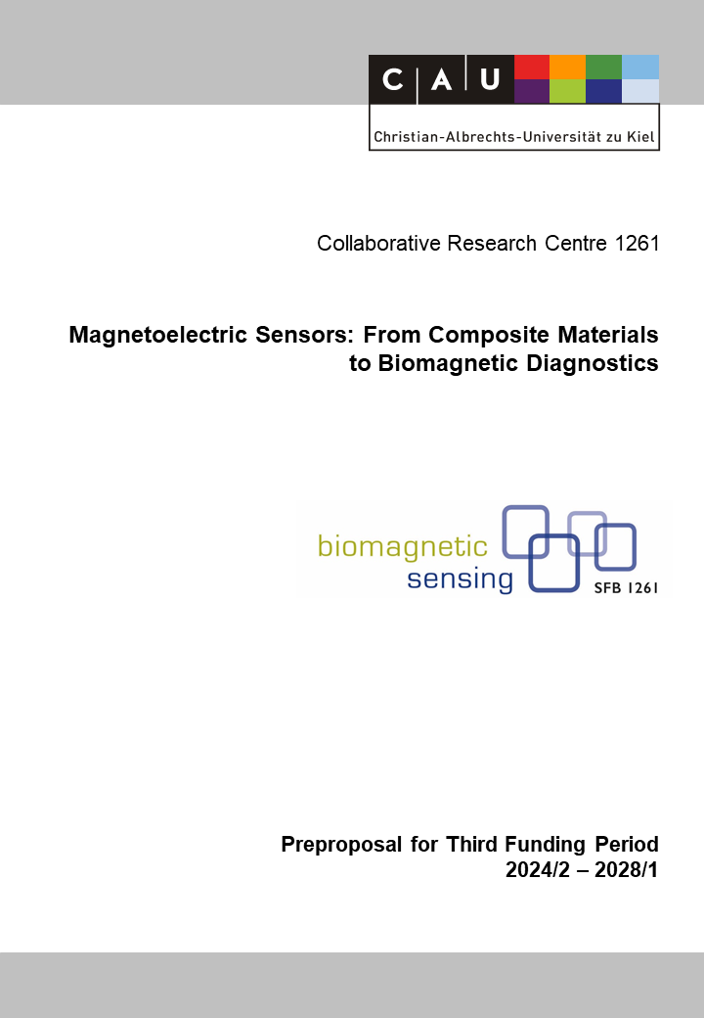

SOP: Scientific Outreach Project
Reviewer (to be removed finally) | Norbert Frey
Reviewer (to be removed finally) | Walter Maetzler
Reviewer (to be removed finally) | Martina Gerken

Principal Investigators
Enzingmüller, Carolin, Dr.  17.03.1984  Department of Chemistry Education  Leibniz-Institute for Science and Mathematics  Education (IPN)  Christian-Albrechts-Universität zu Kiel  Olshausenstr. 62, D-24118 Kiel  Phone: +49 (0) 431 880 3145  E-mail: enzingmueller@leibniz-ipn.de | Parchmann, Ilka, Prof. Dr.  11.06.1969  Department of Chemistry Education  Leibniz-Institute for Science and Mathematics  Education (IPN)  Christian-Albrechts-Universität zu Kiel  Olshausenstr. 62, D-24118 Kiel  Phone: +49 (0) 431 880 3494  E-mail: parchmann@leibniz-ipn.de

Summary of the Research Project
The CRC 1261 has developed an effective outreach program, reaching diverse audiences such as the public, school students, and teachers. Early-career researchers have actively participated through collaboration with the iRTG. In the second funding period, the CRC has embraced interactive visualizations as a powerful means of communication in collaboration with the Kiel Science Communication Network. Building on past success, the SOP aims to enhance outreach efforts in the third funding phase with two distinct outreach programs.
Visuals for communication and training: The outreach program focuses on interactive visualizations to effectively communicate CRC research progress, methodologies, and outcomes. By enabling the audience to interact with the visualizations, the CRC aims to foster a deeper understanding and appreciation of its research within the general public and in learning contexts. The SOP will tie the design and creation of interactive visualizations to support measures for junior scientists. This approach offers them opportunities to refine their communication skills, collaborate with experts in visualization design, and contribute to the development of innovative communication tools.
Attracting the next generation: A shortage of engineers is still a major challenge in many countries. To this regard, the CRC offers a promising context as it investigates and develops solutions for medical demands and contexts which have been shown to be of high interest for school students. Building on former goals of the CRC that could not have been fully achieved yet due to the CoVid19 pandemic we aim to set a focus on the development of a study and career orientation program for school students that allows better insights but also an early involvement in CRC topics and research groups. This program will be integrated into school structures, allowing continuous engagement throughout upper secondary education. It will explore factors that influence career aspirations, such as sense of belonging and identity development, through research conducted within the IPN research context and supported by the CRC's iRTG.
The results of the SOP will be communicated through the website of the CRC, journals for teachers and researchers, and they will be presented at conferences and outreach symposia. The SOP will also continue to support public events in cooperation with Kiel University and KiNSIS press offices.

Project-relevant Previous Publications
[1] Broß, C.; Plöger, T.; Enzingmüller, C.; Parchmann, I.: Kristalle unter Spannung: Piezoelektrizität als Beispiel für Struktur-Eigenschafts-Beziehungen. CHEMKON, 29(8), (2022), 240-246. https://doi.org/10.1002/ckon.202100024.
[2] Broß, C.; Enzingmüller, C.; Parchmann, I.; & Schmidt, G.: Teaching magnetoelectric sensing to secondary school students: Considerations for educational STEM outreach. Sensors, 21(21), (2021). https://doi.org/10.3390/s21217354.
{3] Enzingmüller, C.; Broß, C.; Laumann, D., Parchmann, I.; Schmidt, G.: Magnetfelder am Herzen messen. MNU Journal, 74(2), (2021), 149-153.Laumann, D.; Hayes, P.; Enzingmüller, C.; Quandt, E.; & Parchmann, I.: Magnetostriction Measurements with a Low-Cost Magnetostrictive Cantilever Beam, American Journal of Physics, 88(6), (2020), 448-455. https://doi.org/10.1119/10.0000640.
[4] Laumann, D.; Hayes, P.; Enzingmüller, C.; Quandt, E.; Parchmann, I.: Magnetostriction Measurements with a Low-Cost Magnetostrictive Cantilever Beam, American Journal of Physics, 88(6), (2020), 448-455. https://doi.org/10.1119/10.0000640
[5] Enzingmüller, C.; Laumann, D.; Kampschulte, L.; Parchmann, I.: Kommunikation interdisziplinärer Forschung im Bereich Biomagnetic Sensing. In C. Maurer (ed.): Naturwissenschaftliche Bildung als Grundlage für berufliche und gesellschaftliche Teilhabe: Gesellschaft für Didaktik der Chemie und Physik, Jahrestagung in Kiel 2018, Universität Regensburg, (2019), 564-567.
[6] Kampschulte L.; Enzingmüller, C.; Wentorf, W.; Quandt, E.; Parchmann, I.: Medizinische Sensoren entwickeln: Zusammenarbeit verschiedener Disziplinen. Naturwissenschaften im Unterricht – Chemie, 29(164), (2018), 41-45.
[7] Sevian, H.; Dori, Y. J.; Parchmann, I.: How does STEM context-based learning work: what we know and what we still do not know, International Journal of Science Education, 40:10, (2018), 1095-1107.
[8] Blankenburg, J.; Höffler, T.; Parchmann, I.: Fostering today what is needed tomorrow: Investigating students’ interest in science. Science Education, 100(2), (2016), 364-391.
[9] Parchmann, I.; Kampschulte, L.: Bildung im digitalen Zeitalter - Perspektiven und Möglichkeiten außerschulischer Lernorte. In Paderborner Podium. Paderborn: Heinz Nixdorf MuseumsForum, (2017), 128-143.
[10] Tirre, F.; Kampschulte, L.; Thoma, G.-B.; Höffler, T.; Parchmann, I.: Design of a student lab program for nanoscience and technology – An intervention study on students’ perceptions of the nature of science, the nature of scientists and the nature of scientific inquiry. Research in Science & Technological Education, (2018).

