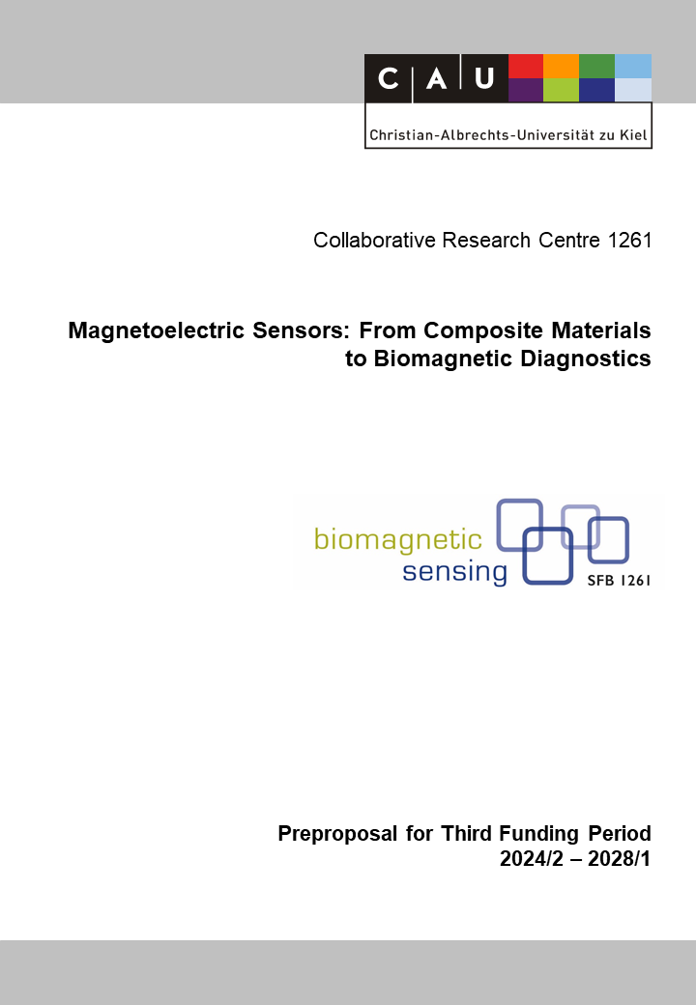

B9: Magnetoelectric Sensors for Movement Detection and Analysis
Reviewer (to be removed finally) | Ann-Kristin Helmers
Reviewer (to be removed finally) | Julius Pochhammer
Reviewer (to be removed finally) | Fabian Lofink

Principal Investigators
Maetzler, Walter Prof. Dr. med.  09.09.1971  Neurogeriatrics  Department of Neurology, University Hospital  Schleswig-Holstein, Campus Kiel  Christian-Albrechts-Universität zu Kiel  Arnold-Heller-Str. 3, Haus 41, D-24105 Kiel  Phone: +49 (0) 431 500 23981  E-mail: w.maetzler@neurologie.uni-kiel.de | Schmidt, Gerhard, Prof. Dr.-Ing  23.11.1971  Digital Signal Processing and System Theory  Institute for Electrical Engineering and Information Engineering  Christian-Albrechts-Universität zu Kiel  Kaiserstr. 2, D-24143 Kiel  Phone: +49 (0) 431 880 6125  E-mail: gus@tf.uni-kiel.de
Summary of the Research Project
This project investigates the potential of an entirely novel movement detection strategy based on magnetoelectric (ME) sensors to detect pathological movement. Parkinson’s disease, stroke, and Multiple Sclerosis serve as model diseases. We argue that an ME-based movement detection and analysis system combines advantages of ambulatory movement detection techniques (e.g., flexible use, affordable, exact, and objective), while over-coming relevant disadvantages and shortcomings of currently used movement detection systems (for example, it allows analysis of relative movement between sensors, network analysis across sensors, and does not have drift).
During the first funding period (2019-2023), we initially demonstrated the application of ME sensors in motion analysis based on a simplified 1D motion scenario. To transfer these results into medical applications, a comprehensive real-time simulation pipeline (digital twin) based on a kinematic and a magnetic model was established. Subsequently, a method for full 6D motion sensing in a distributed sensor/actuator network was developed. This includes collaboration with related CRC projects to develop novel 3D ME sensors and 3D actuators. The method was applied to the estimation of foot kinematics in a clinical pilot study.
Eventually, by the end of this funding period, a detection algorithm for human movements in the range of 40-50 cm (sensor-actuator distance) is available, which has an accuracy of few cm, and can be used to distinguish between physiological and pathological movements, e.g. during walking. This algorithm can be applied in parallel to a network of at least two coils and three sensors.
Our central goal for the next funding period is the advancement of our system towards a home assessment-like scenario. AI-based algorithms like deep neural networks are to be used in both activity and pathology classification. We propose algorithm training based on databases established as part of the Keep Control project (Warmerdam et al. 2021 & 2022), supported by our digital twin approach (data generation and augmentation). The hardware is to be improved to the extent that a scaled up wearable sensor/actuator network can be operated in a performance-optimized and power-efficient way. This includes the exploitation of ME sensor-specific features like activity detection and resonance frequency-shifting. The detection algorithm is to incorporate data from supplementary sensors (like inertial measurement units) in terms of a sensor fusion approach.
This system will substantially add to our general understanding of physiological and pathological human movement under supervised and unsupervised conditions.

Project-relevant Previous Publications
[1] Hoffmann, J.; Bald, C.; Schmidt, T.; Boueke, M.; Engelhardt, E.; Krüger, K.; Elzenheimer, E.; Hansen, C.; Maetzler, W.; Schmidt, G.: Designing and Validating Magnetic Motion Sensing Approaches with a Real-time Simulation Pipeline. Current Directions in Biomedical Engineering, (2023), (accepted).
[2] Hoffmann, J.; Roldan-Vasco, S.; Krüger, K.; Niekiel, F.; Hansen, C.; Maetzler, W.; Orozco-Arroyave, J.R.; Schmidt, G.: Pilot Study: Magnetic Motion Analysis for Swallowing Detection Using MEMS Cantilever Actuators. Sensors, (2023), 3594, DOI: 10.3390/s23073594 (open access).
[3] Hoffmann, J.; Hansen, C.; Maetzler, W.; Schmidt, G.: A Concept for 6D Motion Sensing with Magnetoelectric Sensors. Current Directions in Biomedical Engineering 8(2), (2022), 451-454, DOI: 10.1515/cdbme-2022-1115 (open access).
[4] Romijnders, R.; Warmerdam, E.; Hansen, C.; Schmidt, G.; Maetzler, W.: A Deep Learning Approach for Gait Event Detection from a Single Shank-Worn IMU: Validation in Healthy and Neurological Cohorts. Sensors (Basel). 2022 May 19.;22(10):3859, DOI: 10.3390/s22103859 (open access).
[5] Warmerdam, E.; Hansen, C.; Romijnders, R.; Hobert., M.A.; Welzel, J.; Maetzler, W.: Full-Body Mobility Data to Validate Inertial Measurement Unit Algorithms in Healthy and Neurological Cohorts. Data 2022.; 7.; 136, DOI: 10.3390/data7100136 (open access).
[6] Hoffmann, J.; Elzenheimer, E; Bald, C.; Hansen.; C.; Maetzler, W.; Schmidt, G.: Active Magnetoelectric Motion Sensing: Examining Performance Metrics with an Experimental Setup. Sensors.; (2021).; 8000, DOI: 10.3390/s21238000 (open access).
[7] Romijnders, R.; Warmerdam, E.; Hansen, C.; Welzel, J.; Schmidt, G.; Maetzler, W.: Validation of IMU-based gait event detection during curved walking and turning in older adults and Parkinson’s Disease patients. J Neuroeng Rehabil. 2021 Feb 6.;18(1):28, DOI: 10.1186/s12984-021-00828-0 (open access).
[8] Warmerdam, E.; Romijnders, R.; Hansen, C.; Elshehabi, M.; Zimmermann, M.; Metzger, FG.; von Thaler, AK.; Berg, D.; Schmidt G.; Maetzler W.: Arm swing responsiveness to dopaminergic medication in Parkinson’s disease depends on task complexity. NPJ Parkinsons Dis. 2021 Oct 5.;7(1):89, DOI: 10.1038/s41531-021-00235-1 (open access).
[9] Warmerdam, E.; Romijnders, R.; Geritz, J.; Elshehabi, M.; Maetzler, C.; Otto, JC.; Reimer, M.; Stuerner, K.; Baron, R.; Paschen, S.; Beyer, T.; Dopcke, D.; Eiken, T.; Ortmann, H.; Peters, F.; Recke, FV.; Riesen, M.; Rohwedder, G.; Schaade, A.; Schumacher, M.; Sondermann, A.; Maetzler, W.; Hansen, C.: Proposed Mobility Assessments with Simultaneous Full-Body Inertial Measurement Units and Optical Motion Capture in Healthy Adults and Neurological Patients for Future Validation Studies: Study Protocol. Sensors (Basel). 2021 Aug 30.;21(17):5833, DOI: 10.3390/s21175833 (open access).
[10] Warmerdam, E.; Romijnders, R.; Welzel, J.; Hansen, C.; Schmidt, G.; Maetzler, W.: Quantification of Arm Swing during Walking in Healthy Adults and Parkinson’s Disease Patients: Wearable Sensor-Based Algorithm Development and Validation. Sensors (Basel). 2020 Oct 21.;20(20):5963, DOI: 10.3390/s20205963 (open access).

