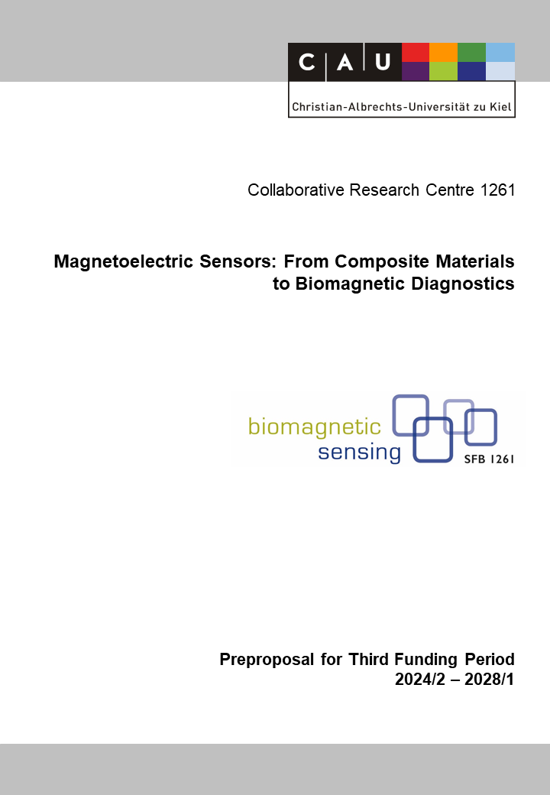

B13(N): Magnetic Smart Pill for Colon Analysis
Reviewer (to be removed finally) | Robert Bergholz
Reviewer (to be removed finally) | Florian Niekiel
Reviewer (to be removed finally) | Günther Deuschl

Principal Investigators
Ellrichmann, Mark, Prof.  14.01.1975  Interdisciplinary Endoscopy,  Medical Department 1  University Hospital Schleswig-Holstein,  Campus Kiel  Christian-Albrechts-Universität zu Kiel  Arnold-Heller-Str. 3, Haus C, D-24105 Kiel  Phone: +49 (0) 431 500 22373  E-mail: mark.ellrichmann@uksh.de | Lofink, Fabian, Prof. Dr. rer. nat.  05.09.1977  MEMS-Applications  Fraunhofer Institute for Silicon Technology  Fraunhoferstr. 1, D-25524 Itzehoe  Phone: +49 (0) 4821 17 1198  E-mail: fabian.lofink@isit.fraunhofer.de
Summary of the Research Project

Gastrointestinal motility refers to the coordinated movement of the digestive tract, allowing for the proper digestion and absorption of nutrients. Several gastrointestinal and neurological diseases are closely associated with abnormal motility especially of the small bowel. Conditions such as irritable bowel syndrome (IBS), gastroparesis, chronic intestinal pseudo-obstruction, and inflammatory bowel disease (IBD) often exhibit disruptions in gastrointestinal motility which result in symptoms like abdominal pain, bloating, constipation, diarrhea, and malabsorption of nutrients significantly impacting the patient`s quality of life.
Diagnosing and evaluating gastrointestinal motility disorders pose challenges in clinical practice. Currently, only a limited number of modalities are available to quantify or visualize gastrointestinal functionality. However, the existing diagnostic options have notable limitations in clinical settings: low sensitivity, time-consuming procedures, and high costs. Moreover, most existing methods lack the ability to assess gastrointestinal motility during physical activity, which is important for understanding real-life functioning.
Current smart pills applied for intestinal diagnostics are swallowed and then record different measured values with their integrated sensors during movement in the intestinal tract. For motility diagnostics, such pills have only a very limited use due to their poor or no spatial resolution of their own position. As current smart pills are active and thus require a substantial number of electronic components and a battery, they also have a considerable large size of about 3 cm in length. Thus, swallowing is at least uncomfortable, in many cases even impossible. Especially for patients with pathological situations in the intestine such as strictures, these large sizes of the pills can lead to a contraindication. As a result, the use of today's smart pills is often not possible in diagnostically relevant cases.
In the current funding period, the use of ME sensors for the diagnosis of motility of the intestinal tract is to be investigated in this new project. It will investigate whether the use of a significant smaller (~ 5 mm) and battery-free magnetic probe (in vivo) for the diagnosis of motility in the intestine is feasible, and how its 3D movement in the human body can be detected with magnetoelectric (ME) sensors (ex vivo). Finally, the question will be answered whether this approach is even suitable for use in diagnostics under everyday conditions. The magnetic probe to be applied is a MEMS cantilever with an integrated hard magnet at its tip that acts as a narrow-band transmitter when resonantly excited. In vivo excitation can be provided either by excitation electronics integrated into a probe pill or by external excitation coils. Last would result in a completely passive probe. The cantilever-based ME sensors of the SFB are characterized by a high-quality factor, which leads to a particularly high magnetic sensitivity in the sensors’ resonance combined with a detection limit in the pT regime. Once the sensor frequency is matched to the frequency of the magnetic probe, the ME sensor will listen very sensitive to the probe and simultaneously effectively suppresses interference from other sources. By using several such tuned ME sensors at the same time at various selected positions, a precise 3D localization and tracking of the probe should be possible.
In the project, application studies will be carried out using a torso/intestinal phantom including flow and 3D movement of the probe. The resolution with which a 3D localization and tracking of the magnetic probe with ME-sensors can be realized is studied, and whether localization is even possible when the patient is moving. Battery-free operation of the probe is also explored, and miniaturization < 1 cm³ of the probe is pursued.
In a second study, the applicability of the above-described magnetoelectric 3D mapping in the context of endoscopy is to be investigated. The field of flexible endoscopy has revolutionized the way we diagnose and treat various medical conditions within the human body. Flexible endoscopes, equipped with a light source and a camera, are commonly used in clinical practice to visualize and access internal organs, tissues, and cavities. However, one significant challenge that clinicians face during endoscopic procedures is accurately tracking the distal tip of the endoscope within the complex anatomy of the human body.
So far, only one approach is available on the market for the use in colonoscopy involving an electromagnetic tracking system. These systems utilize sensors embedded in the endoscope and an external electromagnetic field generator to track the position and orientation of the distal tip. This system only visualizes the geometric position of the scope without any relation to anatomical landmarks within the human body. Therefore, electromagnetic actuators, developed in this project, will be attached to the distal tip of an endoscope, respective signals will be picked up by ME-sensors at the body surface of the patient thereby calculating the precise position and orientation of the scope withing the body in a three-dimensional image in relation to anatomical landmarks defined by CT scan or MRI.

Hinweis auf Lokalisierung in B2

Project-relevant Previous Publications
[1] Bodduluri, M. T.; Gojdka, B.; Wolff, N.; Kienle, L.; Lisec, T.; Lofink, F.: Investigation of Wafer-Level Fabricated Permanent Micromagnets for MEMS, Micromachines, 13(5), 742 (2022), 10.3390/mi13050742.
[2] Gojdka, B.; Dankwort, T.; Lisec, T.; Nowak, M.-A.; Bodduluri, M.-T.; Ahmed, M.; Grünzig, S.; Lofink, F.: Magnetically excited piezoelectric Energy Harvester for micropower supply and wakeup applications, Sensors Actuators and Microsystems, 455 (2021), 10.1109/Transducers50396.2021.9495625.
[3] Spetzler, B.; Su, J.; Friedrich, R.-M.; Niekiel, F.; Fichtner, S.; Lofink, F.; Faupel F.: Influence of the piezoelectric material on the signal and noise of magnetoelectric magnetic field sensors based on the delta-E effect, APL Materials 9, 031108 (2021), 10.1063/5.0042448.
[4] Ellrichmann, M.; Bethge, J.; Boesenkoetter, J.; Conrad, C.; Noth, R.; Bahmer, T.; Nikolaus, S.; Aden, K.; Zeissig, S.; Schreiber, S.: Subclinical Pulmonary Involvement in Active IBD Responds to Biologic Therapy. J Crohns Colitis, vol. 2, no. 15, pp. 1339-1345, 2021, 10.1093/ecco-jcc/jjab024.
[5] Su, J.; Niekiel, F.; Fichtner, S.; Kirchhof, C.; Meyners, D.; Quandt, E.; Wagner, B.; Lofink, F.: Frequency tunable resonant magnetoelectric sensors for the detection of weak magnetic field, J. Micromech. Microeng. 30, 075009 (2020), DOI: 10.1088/1361-6439/ab8dd0.
[6] Zuo, S.; Schmalz, J.; Özden, M.-Ö.; Su, J.; Niekiel, F.; Lofink, F.; Gerken, M.; Nazarpour, K.; Heidari, H.: Ultrasensitive Magnetoelectric Sensing System for Pico-Tesla MagnetoMyoGraphy: IEEE Trans. Biomed. Circuits. Sys. 14(5),971 (2020), DOI: 10.1109/TBCAS.2020.2998290.
[7] Yarar, E.; Fichtner, S.; Hayes, P.; Piorra, A.; Reimer, T.; Lisec, T.; Frank, P.; Wagner, B. Lofink, F.; Meyners, D.; Quandt, E.: MEMS-based AlScN Resonating Energy Harvester with Solidified Powder Magnet, J. Microelectromech. S., 1057 (2019), DOI: 10.1109/JMEMS.2019.2945550.
[8] Niekiel, F.; Su, J.; Bodduluri, M. T.; Liseca, T.; Blohm, L.; Pieper, I.; Wagner, B.; Lofink, F.: Highly Sensitive MEMS Magnetic Field Sensors with Integrated Powder-based Permanent Magnets, Sensors and Actuators A 297, 111560 (2019), DOI: 10.1016/j.sna.2019.111560.
[9] Ye, L.; Yuan, X.; Pang, M.; Bethge, J.; Ellrichmann, M.; Du, J.; Zeng, X.; Tang, C.; Schreiber, S.; Hu, B.: Magnetic bead-assisted endoscopic submucosal dissection: a gravity-based traction method for treating large superficial colorectal tumors. Surg Endosc., vol. 33, no. 6, pp. 2034-2041, 2019, DOI: 10.1007/s00464-019-06799-7.
[10] Zeissig, S.; Rosati, E.; Dowds, C.M.; Aden, K.; Bethge, J.; Schulte, B.; Pan, W.H.; Mishra, N., Zuhayra, M.; Marx, M.; Paulsen, M.; Strigli, A.; Conrad, C.; Schuldt, D.; Sinha, A.; Ebsen, H.; Kornell, S.C.; Nikolaus, S.; Arlt, A.; Kabelitz, D.; Ellrichmann, M.; Lützen, U.; Rosenstiel, P.C.; Franke, A.; Schreiber, S.: Vedolizumab is associated with changes in innate rather than adaptive immunity in patients with inflammatory bowel disease. Gut, vol. 68, no. 1, pp. 25-39, 2019, DOI: 10.1136/gutjnl-2018-316023.
[11] Ellrichmann, M.; Wietzke-Braun, P.; Dhar, S.; Nikolaus, S.; Arlt, A.; Bethge, J.; Kuehbacher, T.; Wintermeyer, L.; Balschun, K.; Klapper, W.; Schreiber, S.; Fritscher-Ravens, A.: Endoscopic ultrasound of the colon for the differentiation of Crohn's disease and ulcerative colitis in comparison with healthy controls. Aliment Pharmacol Ther., vol. 39, no. 8, pp. 823-833, 2014, DOI: 10.1111/apt.12671.

Eine Referenzen entfernen

