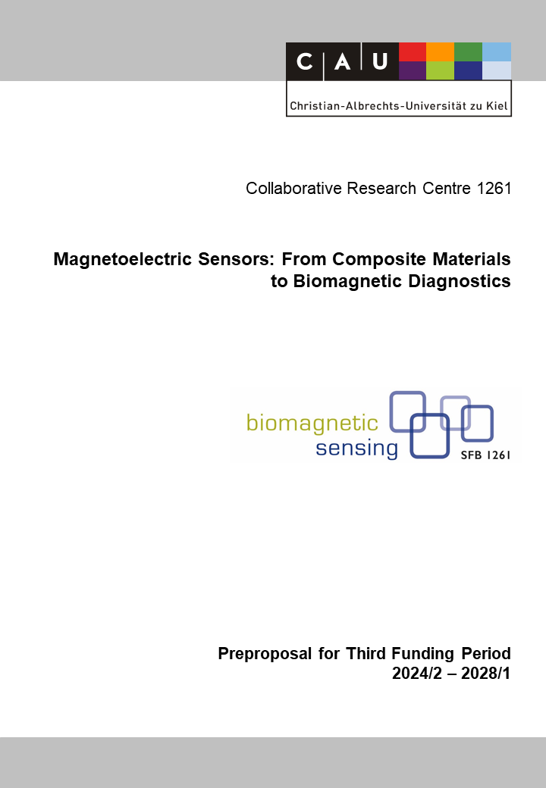

A7: Electrically Modulated Magnetoelectric Sensors
Reviewers (to be removed finally) | Ch. Selhuber-Unkel
Reviewers (to be removed finally) | Stephan Wulfinghoff
Reviewers (to be removed finally) | Jeffrey McCord

Principal Investigator
Quandt, Eckhard, Prof. Dr.-Ing.
05.04.1960

Inorganic Functional Materials
Institute for Materials Science
Christian-Albrechts-Universität zu Kiel
Kaiserstr. 2, D-24143 Kiel

Phone: +49 (0) 431 880 6200
E-mail: eq@tf.uni-kiel.de

Summary of the Research Project
Research of the previous funding periods has shown that electrically modulated mesoscopic magnetoelectric composites, targeting high frequency mechanical resonances (the so-called U-modes), far higher than flexural modes, lead to dramatically enhanced overall performance as a magnetic field sensor. In this approach the high frequency resonances are excited with the piezoelectric layer while the sensor is immersed in an inductor, using the converse magnetoelectric effect via the induced voltage as the sensor signal.
In the second funding period the use of exchange biased multilayer dedicated for the inverse magnetoelectric effect resulted in a significant improvement of the limit of detection (LOD). The LODs for sensors using single layer magnetostrictive materials (200 pT/Hz^{1/2} at DC and 70 pT/Hz^{1/2} at 10 Hz) could be improved by an order of magnitude to 16 pT/Hz^{1/2} at DC and 7.5 pT/Hz^{1/2} at 10 Hz. These LODs - which are the best within the CRC - in combination with the bandwidth of about 1 kHz have led to the fact that these sensors could be used for first magnetocardiological investigations.
The research in the third funding period will focus on a further improvement of the achievable LODs by using specifically designed multilayer films (in close collaboration with project A1), by increasing the frequency of the employed U-mode into the low MHz range, by changing the design of the resonator in order to achieve homogeneous stress states within the detection coil and to investigate alternative clamping concepts in order to reduce drift of the resonance frequency, e.g., due to temperature variations. In collaboration with subproject B9, the sensors will be used for more advanced magnetocardiological investigations. According to the specific requirements, the property profile will be adapted accordingly.

Project-relevant Previous Publications
[1] Elzenheimer, E.; Hayes, P.; Thormählen, L.; Engelhard, E.; Zaman, A.; Quandt, E.; Frey, N.; Höft, M.; Schmidt, G.: Investigation of Convers Magnetoelectric Thin-Film Sensors for Magnetocardiography, IEEE Sensors Journal 23 (2023), 5660-5669, DOI: 10.1109/JSEN.2023.3237910
[2] Elzenheimer, E.; Bald, C.; Engelhardt, E.; Hoffmann, J.; Hayes, P.; Arbustini, J.; Bahr, A.; Quandt, E.; Höft, M.; Schmidt, G.: Quantitative Evaluation for Magnetoelectric Sensor Systems in Biomagnetic Diagnostics, Sensors 22 (2022), 1018, https://doi.org/10.3390/s22031018.
[3] Liang, X.; Matyushov, A.; Hayes, P.; Schell, V.; Dong, C.; Chen, H.; He, Y.; Will-Cole, A.; Quandt, E.; Martins, P.; McCord, J.; Medarde, M.; Lanceros-Méndez, S.; van Dijken, S.; Sun, N. X.; Sort, J.: Roadmap on Magnetoelectric Materials and Devices, IEEE Transactions on Magnetics 57 (2021), 400157, DOI:10.1109/TMAG.2021.3086635
[4] Urs, N. O.; Golubeva, E.; Röbisch, V.; Toxvaerd, S.; Deldar, S.; Knöchel, R.; Höft, M.; Quandt, E.; Meyners, D.; McCord, J.: Direct Link between Specific Magnetic Domain Activities and Magnetic Noise in Modulated Magnetoelectric Sensors, Physical Review Applied 13 (2020) 024018, DOI: 10.1103/PhysRevApplied.13.024018.
[5] Hayes, P.; Klug, M. J.; Toxværd, S.; Durdaut, P.; Schell, V.; Teplyuk, A.; Burdin, D.; Winkler, A.; Weser, R.; Fetisov, Y., Höft, M.; Knöchel, R.; McCord, J.; Quandt, E.: Converse Magnetoelectric Composite Resonator for Sensing Small Magnetic Fields, Scientific Reports 9 (2019),16355, DOI:10.1038/s41598-019-52657-w.
[6] Tu, C.; Chu, Z-Q.; Spetzler, B.; Hayes, P.; Dong, C.-Z.; Liang, X.-F.; Chen, H.-H.; He, Y.-F.; Lisenkov, I.; Lin, H.; Lin, Y.-H.; McCord, J.; Faupel, F.; Quandt, E.; Sun, N.-X.: Mechanical-Resonance-Enhanced Thin-Film Magnetoelectric Heterostructures for Magnetometers, Mechanical Antennas, Tunable RF Inductors, and Filters, Materials 12 (2019), 2259; DOI:10.3390/ma12142259
[7] Jovičević Klug, M.; Thormählen, L.; Röbisch, V.; Toxværd, S. D.; Höft, M.; Knöchel, R.; Quandt, E.; Meyners, D.; McCord, J.: Antiparallel exchange biased multilayers for low magnetic noise magnetic field sensors. Applied Physics Letters 114 (2019), 192410, DOI: 10.1063/1.5092942.
[8] Hayes, P.; Schell, V.; Salzer, S.; Burdin, D.; Yarar, E.; Piorra, A.; Knöchel, R.; Fetisov, Y.K.; Quandt, E.: Electrically modulated magnetoelectric AlN/FeCoSiB film composites for DC magnetic field sensing, Journal of Physics D: Applied Physics, Vol. 51(2018), doi: 10.1088/1361-6463
[9] Hayes, P.; Salzer, S.; Reermann, J.; Yarar, E.; Röbisch, V.; Piorra, A.; Meyners, D.; Höft, M.; Knöchel, R.; Schmidt, G.; Quandt, E.: Electrically modulated magnetoelectric sensors, Appl. Phys. Lett. 108 (2016), 182902. DOI: 10.1063/1.4948470.
[10] Lage, E.; Kirchhof, C.; Hrkac, V.; Kienle, L.; Jahns, R.; Knöchel, R.; Quandt, E.; Meyners, D.: Exchange biasing of magnetoelectric composites, Nature Materials 11 (2012), 523-529.

Bitte (open access) am Ende jener Referenzen (vor dem Punkt, der manchmal fehlt) hinzufügen, für die das zutrifft.

