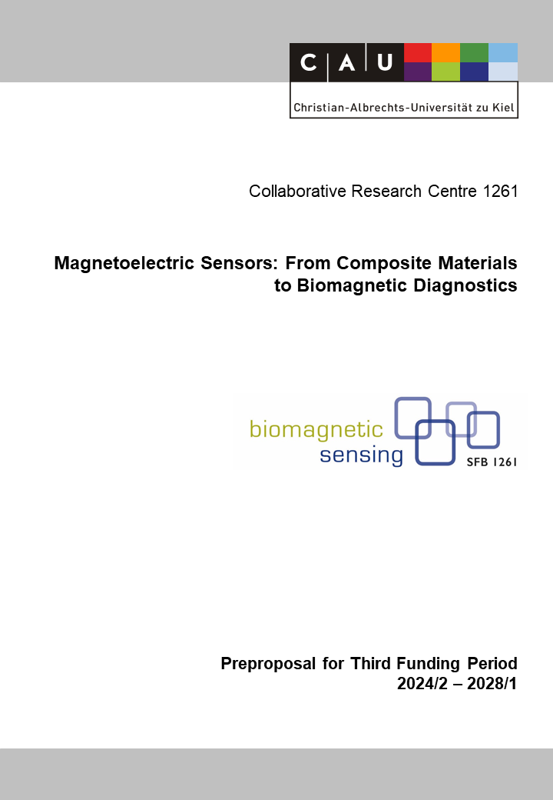
Andreas Bahr

A6: Microstructure and Structural Change of Magnetoelectric and Piezotronic Sensors
Reviewers (to be removed finally) | Andreas Bahr
Reviewers (to be removed finally) | Stefan Schröder
Reviewers (to be removed finally) | Benjamin Spetzler

Principal Investigators
Murphy, Bridget, PD Habil. Dr. rer. nat.  15.06.1969  Ruprecht Haensel Laboratory  Institute of Experimental and Applied Physics  Christian-Albrechts-Universität zu Kiel (CAU)  Leibnizstr. 19, D-24143 Kiel  Phone: +49 (0) 431 880 5558  E-mail: murphy@physik.uni-kiel.de | Kienle, Lorenz, Prof. Dr. rer. nat.  09.04.1967  Synthesis and Real Structure  Institute for Materials Science  Christian-Albrechts-Universität zu Kiel (CAU)  Kaiserstr. 2, D-24143 Kiel  Phone: +49 (0) 431 880 6196  E-mail: lk@tf.uni-kiel.de
Summary of the Research Project
The current limitations of detecting ultralow magnetic fields with state-of-the-art magnetoelectric (ME) sensors impose fundamental material questions to the amorphous and crystalline structure of sensor components. The specific nanostructure and its structural change must be correlated to growth conditions and heat treatments, but also linked to functionality of the operating sensor. Diverse material systems included in thin film sensor concepts are targeted in A6 to examine these structural and functional properties with advanced analytical methods of transmission electron microscopy (TEM) and Synchrotron-based X-ray scattering combining multiscale information with excellent resolution and precision. Together with project partners from A1 we intend to continue the methodological combination of Synchrotron-based pair distribution analysis with advanced electron diffraction techniques to examine the transition from amorphous to (semi-)crystalline states of novel (exchange bias) magnetic (multi-)layer systems (e.g., FeCoSiB, FeCoC, FeGaC, A1) relevant for surface acoustic wave (SAW, A9) and electrically modulated (A7) and ΔE-sensor concepts (A4). A6 aims to understand the impact of sputtering gas pressure and annealing temperatures during sensor preparation and packaging as the essential processing parameters. In situ heating experiments in the TEM and with brilliant Synchrotron X-ray sources will interrelate the short-to-long range ordering with magnetic properties of the sensors.
Together with A9, crystalline piezomaterials (e.g., AlScN) as components of novel SAW thin film sensors will be examined with respect to the crystallographic texture and strain distribution on multiscales. To this context, aberration corrected STEM provides information on epitaxial interface structures and local strain and coherent X-ray diffraction imaging (CXDI) can visualize strain in 3D. The focus will be on the examination of Silicon and Sapphire substrate-based SAW sensor structures during operation to investigate possible substrate losses, e.g. clamping of acoustic waves at structural defects. Novel methodological advances of in operando X-ray scattering will be exploited to design experiments for standing wave excitations and time-resolved pulsed-probe measurements coupled with in situ SEM observations. This approach provides the experimental link between the SAW sensor performance and simulations targeting the material behavior in sensor operation, e.g., the distribution of Rayleigh-wave modes to support the understanding of structural parameters (epitaxial strain, c-axis orientation, etc.) with loss and fatigue phenomena. The ultimate goal of our research is to identify rules for the synthesis and design of tailor-made materials for highly sensitive and low noise magnetoelectric ME sensors.
Project-relevant Previous Publications
[1] Wolff, N.; Braniste, T.; Krüger, H.; Mangelsen, S.; Islam, M. R.; Schürmann, U.; Saure, L. M.; Schütt, F.; Hansen, S.; Terraschke, H.; Adelung, R.; Tiginyanu, I.; Kienle, L. Synthesis and Nanostructure Investigation of Hybrid β-Ga2O3/ZnGa2O4 Nanocomposite Networks with Narrow-Band Green Luminescence and High Initial Electrochemical Capacity. Small 2023, 19 (18), 2207492. https://doi.org/10.1002/smll.202207492 (open acess).
[2] Schell, V.; Spetzler, E.; Wolff, N.; Bumke, L.; Kienle, L.; McCord, J.; Quandt, E.; Meyners, D. Exchange Biased Surface Acoustic Wave Magnetic Field Sensors. Sci Rep 2023, 13 (1), 8446. https://doi.org/10.1038/s41598-023-35525-6 (open acess).
[3] Su, J.; Fichtner, S.; Ghori, M. Z.; Wolff, N.; Islam, M. R.; Lotnyk, A.; Kaden, D.; Niekiel, F.; Kienle, L.; Wagner, B.; Lofink, F. Growth of Highly C-Axis Oriented AlScN Films on Commercial Substrates. Micromachines 2022, 13 (5), 783. https://doi.org/10.3390/mi13050783 (open acess)..
[4] Schönweger, G.; Petraru, A.; Islam, M. R.; Wolff, N.; Haas, B.; Hammud, A.; Koch, C.; Kienle, L.; Kohlstedt, H.; Fichtner, S. From Fully Strained to Relaxed: Epitaxial Ferroelectric Al1-XScxN for III-N Technology. Advanced Functional Materials 2022, 32 (21), 2109632. https://doi.org/10.1002/adfm.202109632 (open acess).
[5] Masciocchi, G.; van der Jagt, J. W.; Syskaki, M.-A.; Lamperti, A.; Wolff, N.; Lotnyk, A.; Langer, J.; Kienle, L.; Jakob, G.; Borie, B.; Kehlberger, A.; Ravelosona, D.; Kläui, M. Control of Magnetoelastic Coupling in Ni/Fe Multilayers Using He+ Ion Irradiation. Appl. Phys. Lett. 2022, 121 (18), 182401. https://doi.org/10.1063/5.0107942.
[6] Wolff, N.; Fichtner, S.; Haas, B.; Islam, M. R.; Niekiel, F.; Kessel, M.; Ambacher, O.; Koch, C.; Wagner, B.; Lofink, F.; Kienle, L. Atomic Scale Confirmation of Ferroelectric Polarization Inversion in Wurtzite-Type AlScN. Journal of Applied Physics 2021, 129 (3), 034103. https://doi.org/10.1063/5.0033205.
[7] Wolff, N.; Jordt, P.; Jetter, J.; Vogt, H.; Lotnyk, A.; Seemann, K.; Ulrich, S.; Quandt, E.; Murphy, B. M.; Kienle, L. Nanostabilization of Tetragonal Distorted FeCo Variants in Ultra-Thin FeCo/TiN Multilayer Films. Materials Characterization 2021, 172, 110871. https://doi.org/10.1016/j.matchar.2021.110871.
[8] Islam, Md. R.; Wolff, N.; Yassine, M.; Schönweger, G.; Christian, B.; Kohlstedt, H.; Ambacher, O.; Lofink, F.; Kienle, L.; Fichtner, S. On the Exceptional Temperature Stability of Ferroelectric Al1-XScxN Thin Films. Appl. Phys. Lett. 2021, 118 (23), 232905. https://doi.org/10.1063/5.0053649.
[9] Jordt, P.; Wolff, N.; Hrkac, S. B.; Shree, S.; Wang, D.; Harder, R. J.; Kübel, C.; Adelung, R.; Shpyrko, O. G.; Magnussen, O. M.; Kienle, L.; Murphy, B. M. Visualizing Intrinsic 3D-Strain Distribution in Gold Coated ZnO Microstructures by Bragg Coherent X-Ray Diffraction Imaging and Transmission Electron Microscopy with Respect to Piezotronic Applications. Advanced Electronic Materials 2021, 7 (11), 2100546. https://doi.org/10.1002/aelm.202100546 (open acess).
[10] Jordt, P.; Hrkac, S. B.; Gröttrup, J.; Davydok, A.; Krywka, C.; Wolff, N.; Kienle, L.; Adelung, R.; Magnussen, O. M.; Murphy, B. M. Local Strain Distribution in ZnO Microstructures Visualized with Scanning Nano X-Ray Diffraction and Impact on Electrical Properties. Advanced Engineering Materials 2021, 23 (11), 2100201. https://doi.org/10.1002/adem.202100201 (open acess).

