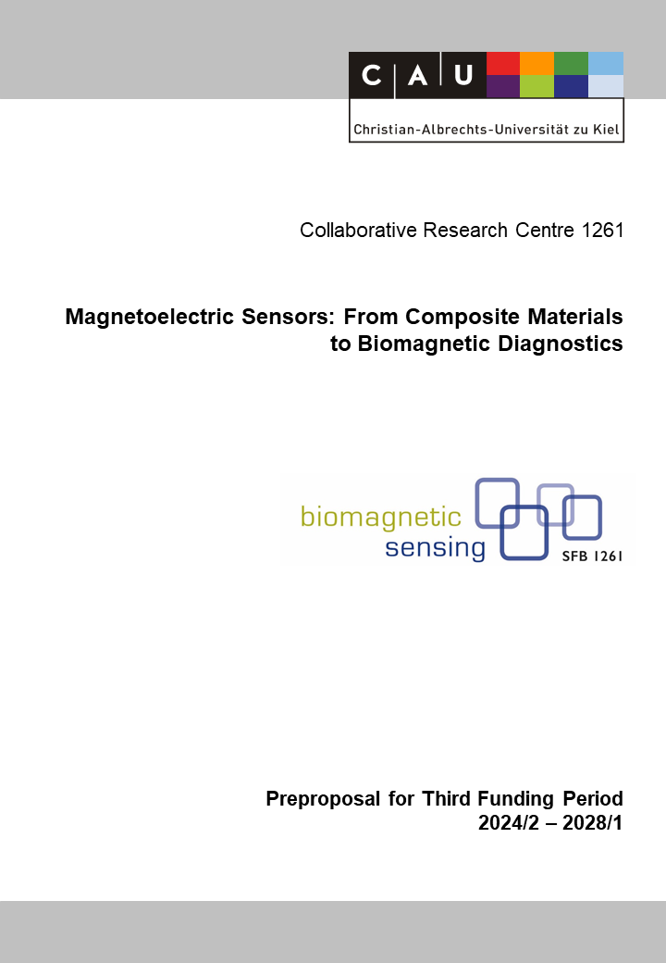

A4: Development of Mechanically Soft Composite Magnetoelectric Multisensory for Wearable Devices
Reviewers (to be removed finally) | Jeffrey McCord
Reviewers (to be removed finally) | Zeynep Altintas
Reviewers (to be removed finally) | Benjamin Spetzler

Principal Investigators
Rieger, Robert, Prof. Dr.  26.10.1975  Networked Electronic Systems  Institute of Electrical and Information  Engineering  Christian-Albrechts-Universität zu Kiel  Kaiserstr. 2, D-24143 Kiel  Phone: +49(0) 431 880 6151  E-mail: rri@tf.uni-kiel.de | Spetzler, Benjamin, Dr.-Ing.  29.04.1992  Micro- and Nanoelectronic Systems  Department of Electrical Engineering and  Information Technology  Technische Universität Ilmenau  Ehrenbergstraße 29, D-98693 Ilmenau  Phone: +49 (0) 3677 69- 3222  E-mail: benjamin.spetzler@tu-ilmenau.de
Summary of the Research Project
This project focuses on developing self-contained sensing dice for planar and 3D magnetic field detection based on miniaturized matrices of ∆E-effect sensors. Grounded on the theory and technology developed in the previous funding period, we will establish spatially resolved multi-directional measurements with miniature sensor arrays not available to-date. Such matrices with high spatial resolution or more than a few independent sensor elements do not exist. Addressing these shortcomings is especially essential for applications targeting mobile measurements. Robust sensing and communication nodes will be realized in MEMS and ASIC technology to enable a compact design of <1 cm³ as a reliable sensing technology for biomedical applications.
Existing sensor system models will be extended to guide the system design and optimize large-scale, three-dimensional sensor matrices, including flux concentrators and flux guides. Upon these findings, sensing structures will be developed and fabricated for the medical applications pursued in the CRC and beyond. Targeted are two-dimensional sensing fields for spatio-temporal monitoring of magnetic activity as well as tri-axial sensing cubes. Each structure will include miniaturized electronics for edge-based signal processing, power management, and communication. This will be done using heterogeneous integration with COTS, MEMS, and ASIC technology.
A close collaboration is envisioned with other projects in the CRC. The sensor fabrication will be based on the shadow-mask technology developed in the previous funding period in A4 and be done in collaboration with A1, Z1, and A6. The electronics development is founded in the sub-circuits and concepts previously developed in A4, which will be used to realize the novel matrix readout and processing electronics. The new concepts and implementations are researched in collaboration with B1 and Z2. Project A4 will maintain continuous engagement with the application projects B10 and B11(N) and supply sensor systems for measurements. Similarly, A4 will provide existing signal and noise models and samples to explore the origin of magnetic noise in collaboration with project A10. It is envisioned that the results and systems realized in this project will also directly impact cutting-edge research beyond this consortium, specifically building fruitful links of exchange with the neighboring CRC 1461 hosted in Kiel that deals with brain-inspired neuromorphic circuits.

Project-relevant Previous Publications
[1] Spetzler, B.; Bald, C.; Durdaut, P.; Reermann, J.; Kirchhof, C.; Teplyuk, A.; Meyners, D.; Quandt, E.; Höft, M.; Schmidt, G.; Faupel, F.: Exchange biased delta-E effect enables the detection of low frequency pT magnetic fields with simultaneous localization, Scientific Reports, 11(1), (2021) 5269, doi: 10.1038/s41598-021-84415-2 (open access).
[2] Spetzler, B.; Wiegand, P.; Durdaut, P.; Höft, M.; Bahr, A.; Rieger, R.; Faupel, F.: Modeling and parallel operation of exchange-biased delta-E effect magnetometers for sensor arrays, Sensors, 21(22), (2021) 7594, doi: 10.3390/s21227594 (open access).
[3] Matyushov, A. D.; Spetzler, B.; Zaeimbashi, M.; Zhou, J.; Qian, Z.; Golubeva, E. V.; Tu, C.; Guo, Y.; Chen, B. F.; Wang, D.; Will-Cole, A.; Chen, H.; Rinaldi, M.; McCord, J.; Faupel, F.; Sun, N. X.: Curvature and stress effects on the performance of contour-mode resonant ∆E effect magnetometers, Advanced Materials Technologies, 6(9), (2021) 2100294, doi: 10.1002/admt.202100294.
[4] Spetzler, B.; Golubeva, E. V.; Friedrich, R.-M.; Zabel, S.; Kirchhof, C.; Meyners, D.; McCord, J.; Faupel, F.: Magnetoelastic coupling and delta-E effect in magnetoelectric torsion mode resonators, Sensors, 21(6), (2021) 2022, doi: 10.3390/s21062022 (open access).
[5] Simmich, S.; Bahr, A.; Rieger, R.: Noise Efficient Integrated Amplifier Designs for Biomedical Applications, Electronics, 10(13), 1522, 2021 doi: 10.3390/electronics10131522 (open access).
[6] Spetzler, B.; Kirchhof, C.; Reermann, J.; Durdaut, P.; Höft, M.; Schmidt, G.; Quandt, E.; Faupel, F.: Influence of the quality factor on the signal to noise ratio of magnetoelectric sensors based on the delta-E effect, Applied Physics Letters, 114(18), (2019) 183504, doi: 10.1063/1.5096001.
[7] Rieger, R.; Rif’an, M.: Integrated ExG, Vibration and Temperature Measurement Front-End for Wearable Sensing, IEEE Trans. Circuits Syst. I – Reg. Papers, 65(8), (2018) 2422–2430, doi: 10.1109/TCSI.2017.2785863.
[8] Rieger, R.; Sulistiyanto, N.: Integrated Circuit for Superregenerative Low-Frequency Amplification, IEEE Trans. Circuits Syst. II – Express Briefs, 65(1), (2018) 31–35, doi: 10.1109/TCSII.2017.2672782.
[9] Rieger, R.; Ou, S.-H.: Pulse-Width-Modulating Bio-Signal ADC for Rapid ASIC Design and IP Core Re-use, IEEE Design and Test, 33(4), (2016) 49–60, doi: 10.1109/MDAT.2016.2536657.
[10] Rieger, R.: Signal-Folding for Range-Enhanced Acquisition and Reconstruction, IEEE Trans. Circuits Syst. I – Reg. Papers, 62(10), (2015) 2617–2625, doi: 10.1109/TCSI.2015.2476317.

