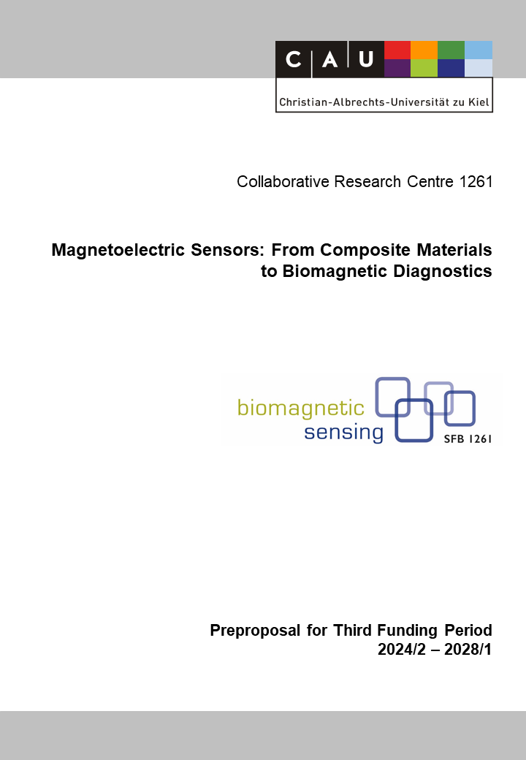

A2: Development of Mechanically Soft Composite Magnetoelectric Multisensory for Wearable Devices
Reviewers (to be removed finally) | Jeffrey McCord
Reviewers (to be removed finally) | Zeynep Altintas
Reviewers (to be removed finally) | Benjamin Spetzler

Principal Investigators
Adelung, Rainer, Prof. Dr. med.  15.03.1971  Functional Nanomaterials  Department of Materials Science  Christian-Albrechts-Universität zu Kiel  Kaiserstr. 2, D-24143 Kiel  Phone: +49 (0) 431 880 6116  E-mail: ra@tf.uni-kiel.de | Amery, Tayebeh, Prof. Dr.  xx.xx.xxxx  xxx  Department of Materials Science  Christian-Albrechts-Universität zu Kiel  Kaiserstr. 2, D-24143 Kiel  Phone: +49 (0) 431 880 xxxx  E-mail: xx@tf.uni-kiel.de
Schröder, Stefan, Dr.
25.04.1989

Multicomponent Materials
Department of Materials Science
Christian-Albrechts-Universität zu Kiel
Kaiserstr. 2, D-24143 Kiel

Phone: +49 (0) 431 880 6232
E-mail: ssch@tf.uni-kiel.de

Summary of the Research Project
Project A2 focuses on the development of a mechanically soft composite magnetoelectric multisensory system for wearable devices. The aim is to explore the potential of bio-magnetic applications in self-powered wearables while fabricating hybrid sensors with enhanced functionality. The project builds upon successful hybrid sensor designs from the current funding period and incorporates various components such as flexible magnetic composite structures, magnetostrictive composites with integrated energy harvesting, micro magnetostrictive composites, and flexible (self-polarized) electret thin films for pseudo piezo materials.
The proposed future work builds upon significant achievements in the current funding period, specifically in flexible magnetic composite structures and flexible (self-polarized) electret thin films. Extensive research has enhanced sensor performance through integrated energy harvesting in magnetostrictive composites. Highly stable corona-charged thin film electrets and tuneable pseudo piezoelectric soft materials have also been developed. This solid foundation enables refinement for more advanced mechanically soft composite magnetoelectric multisensory systems in wearable devices.
The research project recognizes the huge application potential of unexplored bio-magnetic applications in self-powered wearable devices. It aims to cooperate with application projects from the B area: It could support B9 for the analysis movement disorders through multi-sensory devices. Furthermore, the project will investigate the feasibility of implantable devices (in exchange with B10) and development of a positioning system for minimal invasive surgery, potentially utilizing a self-powered (electro-)magnetic transmitter (B11(N)).
To achieve its objectives, the project will follow a comprehensive work plan. It will ensure the biocompatibility of the developed materials, e.g. focusing on fluorene-free solutions. The project will integrate multisensory input/output functionalities into the system and develop encapsulation techniques for reliable packaging. It will also involve the integration of magnetic and piezoelectric components, along with the design and fabrication of readout structures and wireless ME-EM (Magnetoelectric-Electromagnetic) transducer structures. Close collaboration with the simulation (A10) and microstructural characterization (A6) ensures a comprehensive understanding of the developed mechanically soft composite magnetoelectric multisensory system in theory and microstructure.
Project-relevant Previous Publications
[1] Barg, I.; Kohlmann, N.; Rasch, F.; Strunskus, T.; Adelung, R.; Kienle, L. et al. (2023): Strain‐Invariant, Highly Water Stable All‐Organic Soft Conductors Based on Ultralight Multi‐Layered Foam‐Like Framework Structures. In: Adv Funct Materials 33 (21), Artikel 2212688. DOI: 10.1002/adfm.202212688.
[2] Brinza, M.; Schröder, S.; Ababii, N.; Gronenberg, M.; Strunskus, T.; Pauporte, T.; et al. (2023): Two-in-One Sensor Based on PV4D4-Coated TiO2 Films for Food Spoilage Detection and as a Breath Marker for Several Diseases. In: Biosensors 13 (5). DOI: 10.3390/bios13050538.
[3] Jordt, P.; Wolff, N.; Hrkac, Stjepan B.; Shree, S.; Di W.; Harder, R. J.; et al. (2021): Visualizing Intrinsic 3D‐Strain Distribution in Gold Coated ZnO Microstructures by Bragg Coherent X‐Ray Diffraction Imaging and Transmission Electron Microscopy with Respect to Piezotronic Applications. In: Adv. Electron. Mater. 7 (11), S. 2100546. DOI: 10.1002/aelm.202100546.
Keiner der drei PIs ist Autor!
[4] Ospina, J. D. P.; Langner, S.; Ameri, T.; Brabec, C. J. (2017): Solubility and miscibility for diluted polymers and their extension to organic semiconductors. In: Encyclopedia of Physical Organic Chemistry, 6 Volume Set 1, S. 697.
[5] Schröder, S.; Ababii, N.; Lupan, O.; Drewes, J.; Magariu, N.; Krüger, H. et al. (2022): Sensing performance of CuO/Cu2O/ZnO:Fe heterostructure coated with thermally stable ultrathin hydrophobic PV3D3 polymer layer for battery application. In: Materials Today Chemistry 23, S. 100642. DOI: 10.1016/j.mtchem.2021.100642.
[6] Schröder, S.; Ababii, N.; Brînză, M.; Magariu, N.; Zimoch, L.; Bodduluri, M. T. et al. (2023): Tuning the Selectivity of Metal Oxide Gas Sensors with Vapor Phase Deposited Ultrathin Polymer Thin Films. In: Polymers 15 (3). DOI: 10.3390/polym15030524.
[7] Shadabfar, M.; Ehsani, M.; Khonakdar, H. A.; Abdouss, M.; Ameri, T. (2023): Waterborne conductive carbon paste with an eco-friendly binder. In: Cellulose 30 (3), S. 1759–1772. DOI: 10.1007/s10570-022-04998-5.
[8] RA: Nano Energy, accepted?
[9] Schröder, S.; Brinza, M.; Cretu, V.; Zimoch, L.; Gronenberg, M.; Ababii, N. et al. (2023): A New Approach in Detection of Biomarker 2-propanol with PTFE-coated TiO2 Nanostructured Films. In: accepted manuscript.
[10] Schröder, S.; Hinz, A. M.; Strunskus, T.; Faupel, F. (2021): Molecular Insight into Real-Time Reaction Kinetics of Free Radical Polymerization from the Vapor Phase by In-Situ Mass Spectrometry. In: The Journal of Physical Chemistry A 125 (7), 1661-1667. DOI: https://doi.org/10.1021/acs.jpca.0c11180.

Bitte noch (open access) am Ende vor dem Punkt ergänzen, für jene Paper für die das zutrifft.

